**The chart below shows the expenditure on 3 categories with proportions among residents in the UK in 2004.**

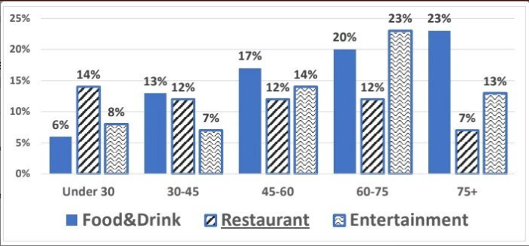

**LẦN 1**

***Hướng dẫn làm bar graph: https://www.ieltstutor.me/blog/bar-chart***

***Diễn đạt số liệu : https://www.ieltstutor.me/blog/so-lieu-task-one-writing***

***Từ vựng biểu đồ không có thời gian https://www.ieltstutor.me/blog/tu-vung-ielts-writing-task-1-bar-table-pie***

The given bar graph demonstrate the proportions of spending on 3 kinds of categories of dwellers in the UK over the year of 2004.

Overall, the expenditure of residents on Food&drink, restaurant and entertainment increased with the ages from under 30 to 75 years old. Among which, only spending on groceries was higher respectively to the ages from the youngs to the elders.

The highest amount of money allocated to food and drink went on people over 75 years old, about 23%. It was clear that young people under 30 tended to spend least money on groceries in 3 categories showed- just more than 5 percent. The figure for restaurant stayed unchanged at 12 percent from the ages of 30 to 75.

**→ Nếu mình chọn miêu tả từng Category là ổn nhé, nhưng với “restaurent” thì mình nên làm rõ thông tin đáng chú ý hơn 1 tí nữa nè.**

**VD:**

**Có dữ liệu là ‘khá giống nhau ở các nhóm tuổi', nhưng cũng nên cho thấy dữ liệu của nhóm tuổi nào là lớn nhất nữa.**

* **Under 30 individuals - nhóm này chi nhiều tiền nhất cho ‘restaurant' nha.**

The highest percentage of cost of entertainment that people in the UK paid in 2004 belonged to group of people from 60-75 years old, with 23%. While the lowest propotion was of 30-45 dwellers. Especially, the figure of entertainment was the least on 3 categories when it comes to resident under 45 with approximately 7.5%.